[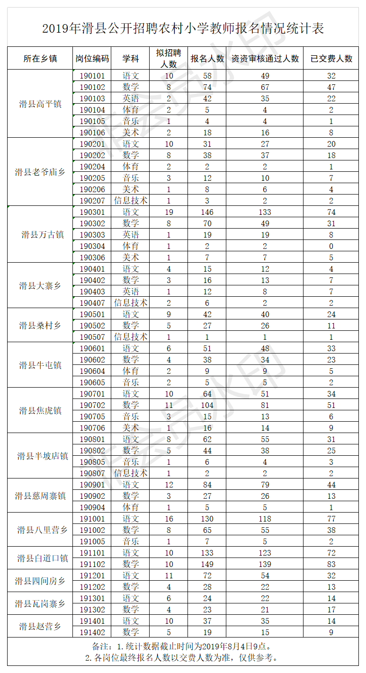](http://hahuaxian.hrss.gov.cn/d/file/xinwenzixun/gonggaogongshi/2019-08-04/27e2027cbaea6eacd39b75efc5ea7d4e.png)